**Block diagram**

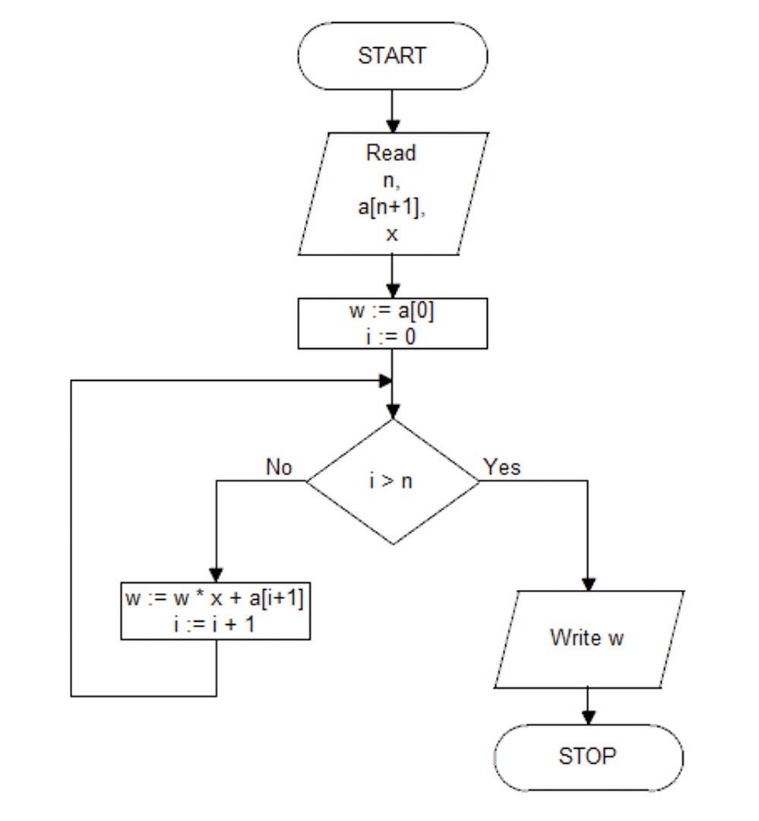

**Pseudocode**

Start:

Read: n, a[n+1], x

w := a[0]

i := 0

for i > n do

w = w * x + a[i + 1]

i++

Write w